

2 Minute Form
Trip Name: Rangitoto / Motutapu Gap
Check-in Name and Phone:
Date: Branch:
Leaders
Cell Phone Number
VHF Call Sign &/or Vessel Name
Vehicle make, model, registration, colour
General Plan
Note: If plan changes, you must notify your Check-in person.
Latest Time Off the Water |  |  |  |  | TMP/ AMP used²⁰ |  |  | Rangitoto Night Paddle
Tide/ Forecast Lake Level | Low |  |  | High
Communications Carried
Communications²¹ | We will be communicating as a group on VHF Channel _____
Equipment Carried
Trip Report
(Use other side if more space required)

Activity | Rangitoto / Motutapu Gap | Centre | Auckland | Location |  |  | Auckland |  | Difficulty¹ |  |  | Strong beginner if conditions are good, otherwise intermediate
Activity Description | Meet at Narrow Neck Beach, paddle across to Rangitoto. It is suggested that if the wind is E or SE, go clockwise; if the wind is N, go anticlockwise. Continue on to the gap. Lunch can be before or after going through the gap depending on timing of the tide. |  |  |  | Leader qualification req.² |  | Club Leader
Get in Location | Narrow Neck |  |  |  | Chart/ Map no.⁴ |  | NZ532 |  | Distance |  |  | 25km
Get out Location | Narrow Neck |  |  |  | Coastguard Channel |  | 80, 82 and 16 |  | Nowcasting |  |  | 21
Emergency get out ⁵ | Any beaches on Rangitoto. |  |  |  | Emergency / Coastguard Station |  |  |  | Phone |  |  | *500  09 303 4303
Emergency get out ⁵ |  |  |  |  | Drinking Water⁶ | Take Own |  | Toilets⁷ |  |  | Narrow Neck, long drop at McKenzies.
Emergency Response | Refer Emergency Response Booklet |  |  |  |  |  |  | Parking⁸ |  |  | Narrow Neck
Specific Equipment Required⁹ | Usual kayaking safety gear. High-viz, flags etc |  |  |  | Working Communications equipment in this area¹⁰ | Cell phone  Sat phone |  |  |  |  |  |  | PLB  VHF
Other resources  and notes¹¹ | Note that kayaks can only get through the gap half an hour either side of high tide when there is a neap tide. King tide provides a little more leeway.  Rangitoto and Motutapu are pest free so please ensure that your kayak and gear are free of rodents, Rainbow skinks, Argentine ants, and weed seeds. |  |  |  | Weather Parameters¹² | Beginner: no significant surf or swell, wind under 15 knots.  Intermediate: surf or ocean swells less than 1.5 metres or wind under 25 knots.  Advanced: any condition that’s suitable for the trip’s aims.
Previous incidents¹³

Safety Management¹⁴
Hazard |  | Significant?  - E/I/M |  | Management Strategy¹⁵ |  |  |  | Hazard | Significant?  - E/I/M | Management Strategy¹⁵
Cold Water |  | Yes - M |  | Carry spare dry clothes and shelter |  |  |  | Deep Water | Yes - E | Correctly fit PFDs
Medical Conditions |  | Yes - M |  | - Leader has first aid qualification  - Ask customers about medical conditions |  |  |  | Bad Weather | Yes - M | Understand weather forecasts.  Have back up plans or pull out if necessary
Capsizing |  | Yes - M |  | - Correctly fit PFDs  - Skills at performing rescues. |  |  |  | Heat / Sun | Yes - M | - Protective Clothing (worn), Sunglasses, Hat  - Sun Screen  - Plenty of drinks
Panic |  | Yes - M |  | Ensure level of skills match conditions. |  |  |  | Obstacles | Yes - M | Awareness of reefs, navigational hazards, nets
Rangitoto Channel |  | Yes- M |  | Very busy shipping channel. Recommend crossing straight over (shortest route). Look out for approaching ships – large vessels move very quickly, are restricted to the channel, and they can’t stop in time to avoid a kayaker, so ensure that you have ample time to cross. Cross the channel in close formation as quickly as possible. |  |  |  | Other Vessels | Yes - M | - Understand the “rules of the sea”  - “Be seen” – Have two of the following; flag, brightly coloured kayak, brightly coloured PFD or hat.
Written up by: | Larraine Williams |  | Approved By: |  | Russell Williams | Signed: | RW |  | Date: | 4 September 2014 | Review in: | 12 months from date of approval

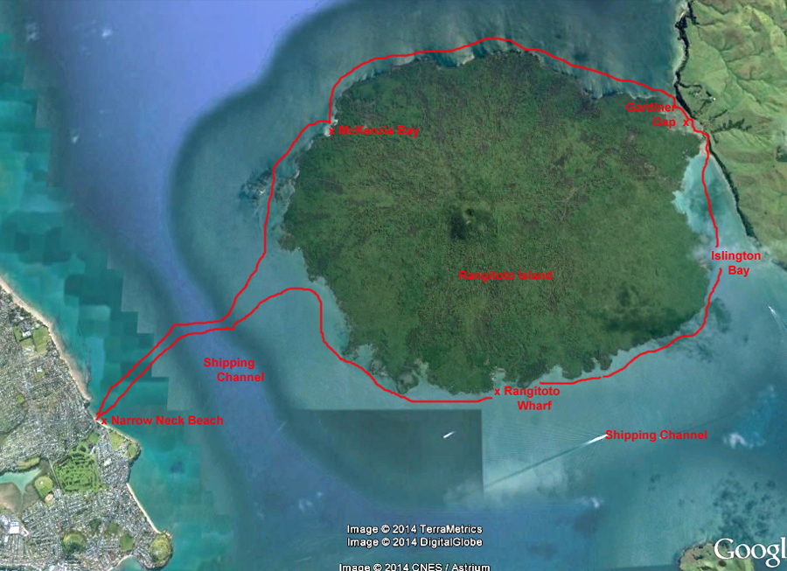

Activity Equipment Check list
Equipment List - Recommended for this Trip
❑ Helmet Rivers and surf Beanie / hat Group Gear
❑ Beanie / hat  Split paddles
❑ Thermals  Repair kit
❑ Paddle Jacket  Fire lighting
❑ PFD  Cooker/thermos
❑ Spray deck  Spare thermals
❑ Booties  Tow system
❑ Water & food  1st Aid Kit
❑ Kayak & paddle  Flares
Group - Oceans & Lakes  Compass
❑ Pumps & Paddle Floats  Charts / Maps
Group - River  GPS (optional)
❑ Throw ropes  Knife (cut rope)
❑ Pin kit & saw  Emergency Shelter
                Night Lights (all round white light and a Torch)

In case of emergency: Dial 111, Mayday :VHF Channel 16

Kayaking Check list

❑ Trip plan
❑ Latest weather forecast
❑ Conditions match skills?
❑ Hyperthermia (hot) &
Hypothermia (cold)
❑ On & off water safety
❑ Environmental concerns
❑ Emergency Procedures include emergency get out.
❑ Working communication devices
e.g. VHF radio, mobile phones, PLB
❑ Specific safety issues for this trip
❑ Participant list
❑ Any medical conditions
❑ All participants keen to proceed?

❑ Trip Plan/ 2-minute form lodged with Ops. Manager

Appropriate wind conditions to run trips:
Novice - no significant surf or swell, wind under 15knots
Intermediate- surf or ocean swells less than 1.5 meter or wind under 25 knots.
Advanced- any condition that is suitable to the trips aims

At conclusion of trip:
Contact check in person
Group Debrief.

Check in Person Ph:
_______________ __ Mobile
__________________ Work
__________________ Home

Activity Document Cover Sheet

Activity:
Date of Activity:
Activity reports. Is all relevant information present:
– Approved Trip Management Plan (TMP)/ 2 minute form
– Club Trip Participant Sheet
– Weather forecast
– Activity Check List
– Trip report (May be on the 2 minute form)
– Accident / incident reports
Leaders Signature:
Date:

